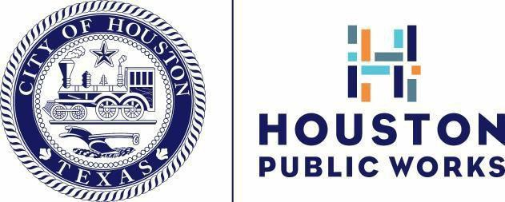

August 2023
Dear Neighbor,

You are receiving this letter because you own a property in a Federal Emergency Management Agency (FEMA) repetitive loss area, a delineated 100- year floodplain, or an area that is subject to repetitive flood loss outside of the Special Flood Hazard Area.

The 100-year floodplain means there is a 1% chance of a flood event occurring in any given year. The 500-year floodplain means there is a 0.2% chance of a flood event occurring in any given year. Approximately 25% of the city lies within the 100-year floodplain. Neighbors in flood-prone areas must be aware of the hazards that may occur during severe storms, hurricanes, or tropical storms.

The City of Houston actively participates in the National Flood Insurance Program (NFIP). Flood insurance is available to you through most major insurance carriers, even if your home has been flooded in the past. Don’t delay, buy flood insurance today as there is a 30-day waiting period before policies are effective. City of Houston homeowners receive a 25% discount on their flood insurance premiums because the city holds a class 5 ranking under FEMA’s Community Rating System.

Houston Public Works is conducting a Repetitive Loss Area Analysis to identify potential solutions to flooding hazards within each individual repetitive loss area. This analysis is ongoing, and most of the data collected is being done remotely; however, we may be visiting some areas to collect additional data in the coming months. Our teams will not enter your private property to collect this data. The analysis results will be provided to city leaders for future flood mitigation efforts. Your personal information will not be disclosed.

The City appreciates the help of those living in repetitive loss areas by providing any information regarding the flooding conditions of your property and we encourage your input. Visit Houstonpublicworks.org to take the survey and provide flooding-related information regarding your property or area. Once completed, copies of the final report will be made available at houstonpublicworks.org and will include a review of alternative approaches for property protection or drainage improvements where feasible.

Prepare for flooding by elevating your HVAC, and by storing insurance paperwork, valuables, and medicine, in a water-protected container. Consider some flood protection measures such as checking your building for water entry points. These can be protected with low walls or temporary shields. Some property protection measures may require a permit. Contact the Floodplain Management Office to find out if a permit is required.
Contact the Houston Public Works grant team at 832.395.3111 for possible grant opportunities that may cover some or all the costs of elevating your house above historic flood levels. Go to Flood Risk Reduction Grants - HoustonRecovers.org for information on financial assistance.

Visit FEMA’s website at www.fema.gov to learn more about the NFIP, availability of flood insurance and property protection measures. Visit FEMA’s Map Service Center at msc.fema.gov for copies of Flood Insurance Rate Maps for your property or call toll-free at 877.336.2627. If you do not have internet access, visit the Floodplain Management Office at 1002 Washington Avenue, or call 832.394.8854.

Sincerely,
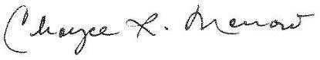
Choyce Morrow, P.E., CFM
Manager, Floodplain Management Office

P.O. Box 1562 | Houston, Texas 77251-1562 | HoustonPublicWorks.org
Capital Projects | Customer Account Services | Houston Permitting Center | Houston Water | Transportation & Drainage Operations

